Draft 4, 12/17/2006 Henry Stewart
An American Life
By David Byron Kimball

12 October 2006
We make our way through the old cemetery at Longstreet, Louisiana. Henry and his wife, Pat wanted to place flowers on the graves of their two grandchildren and on that of his father. As I read the inscription on his father’s marker the words I Love You Daddy go straight into my heart like an arrow and I remember things that Henry has told me; about a time more than half a century earlier when that boy from Mississippi became a man.

Preface
Rarely does one personally come into contact with those who have participated in historical events of great moment. I have had this opportunity. I first became acquainted with Henry Stewart in about 1980 as I began working on my amateur radio license. At that time I didn’t know the history of this gentle man. Gradually the story which I am about to tell emerged as our friendship deepened. It was not something that he really wanted to talk about and I didn’t push him. But as I began to ask questions he responded. What follows is a story about a man and a battleship and covers their intimate association during World War II in the battles of the South Pacific. It is filled with excitement, history and will take the reader on an emotional trip that will cause his sensibilities to range from patriotism to sadness and from exhilaration to terror. Both the man and the ship were among the best that America ever produced. The story is true and the names have not been changed.

Chapter 1
12 May 1920
Henry Stewart is born in the small town of Picayune, Mississippi, which is located just north of the Gulf of Mexico. At the age of 12 his father suffers a disabling double stroke which leaves him paralyzed until his death at the age of 98. His mother works hard as a seamstress, able to make any kind of women’s apparel, but it isn’t enough and Henry has to quit school in the ninth grade and go to work cutting trees in the pulpwood industry. He works in the virgin pine forests – a boy among men at one end of a crosscut saw. It is hard work, but he develops a strong body and endurance that will serve him well for what lies ahead.

“I would take two biscuits and sometimes a sweet potato in a syrup bucket to work every day for my dinner. I made 50 cents a day and was glad to get it. I also sold The New Orleans Times newspaper on Sundays for 10 cents apiece. When I was 13 I went to work for the power company. We were clearing timber for the new power lines that would bring electricity to our state. We were able to do away with our kerosene lanterns and candles after that. The trees we cut down were sold for pulpwood. My wages went up to $1.25 a day.”

As the gravel roads are replaced with asphalt, Henry is offered an old dump truck by a man who has become too sick to drive it anymore. He begins paying it off by leasing it to the Couch Construction Company which has the road building contract. The old truck has no top nor windshield but the hydraulic lift works. Soon a second truck is secured and the future begins to look a little brighter.

“I would take my money home and give it to my mama.”

Prelude to War
April 1937
China and Japan are on the verge of war and the fledgling Chinese Air Force is beset by internal problems. Gen. Claire Chennault accepts an invitation by Madame Chiang Kai-shek to build the Chinese Air Force. This leads to the formation of the American Volunteer Group of P-40 fighter planes better known as The Flying Tigers. On 7 July 1937 the Japanese Air Force attacks and begins its tremendous effort to break the back of Chinese resistance by sustained bombing of every major population center in Free China. The fighting quickly escalates and Japan joins Germany and Italy as part of the Axis Powers. They make rapid progress toward their goal for world domination. The realization of this evil ambition begins to become dangerously clear.

1 September 1939
Germany invades Poland and quickly overruns the small countries of Western Europe with their Blitzkrieg offensive. Next Denmark, Norway and Sweden fall with England soon to come under attack. The dogs of war are loose and even though the mood in America is to stay out of the foreign fray, the time is approaching when she will have to make an important decision.

7 May 1940
President Franklin Delano Roosevelt orders the U.S Fleet headquarters transferred from San Pedro, California to Pearl Harbor, Hawaii. It is an exposed position and he orders it to remain stationed there despite protests by its commander, Adm. Richardson that there is inadequate protection from air attack and no protection from torpedo attack. Richardson feels so strongly that he twice disobeys orders to berth the fleet there and raises the issue personally with FDR in October. He is soon replaced.

His successor, Adm. Kimmel, will also bring up the same issues with FDR one year later. To give him the benefit of the doubt, President Roosevelt might consider the move as a necessary countermeasure to growing Japanese bellicosity. However, Adm. Kimmel is not given access to decoded Japanese radio transmissions and will later be made the scapegoat for the bombing of Pearl Harbor and will be summarily retired from the navy.

It has been said that command in time of war is a lonely outpost. The actions of Sir Winston Churchill regarding the German bombing of Coventry after reading decoded German radio transmissions and those of President Roosevelt regarding the Japanese bombing of Pearl Harbor after reading decoded Japanese radio transmissions are extraordinary examples. They believe that sacrifices have to be made to achieve the greater good.

July 1940
After graduating from the Bible Baptist Seminary at Ft. Worth, Texas, John M. Birch, who had been born in India of American missionary parents and raised in Macon, Georgia, sails for Shanghai, China to also begin serving as a missionary. He quickly learns to speak the Mandarin Chinese dialect and lives off the land as do the peasants to whom he will teach the Gospel. His path will later cross those of two famous American officers,

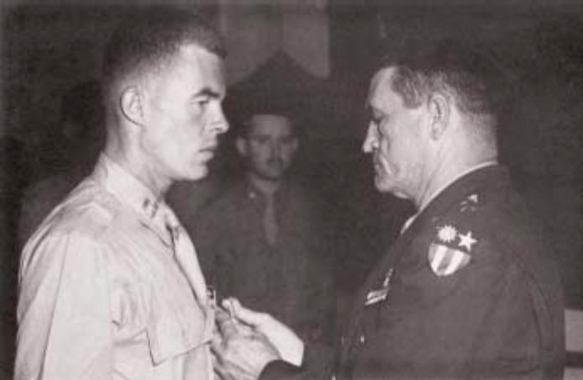
Capt. John M. Birch receiving Legion of Merit
From Gen. Clair Chennault

In the fall of 1940 Generalissimo Chiang Kai-shek instructs Chennault, to go to the United States for the purpose of obtaining American planes and American pilots to end the Japanese bombing. Gen. Chennault's plans call for the injection of a rejuvenated Chinese Air Force spearheaded by American volunteers to upset the Pacific stalemate.

Chapter 2
25 December 1940 - Mississippi
Henry remembers, “It was while I was working for Couch Construction Company that I met a girl named Gloria Brady from Bay Springs and I had to have her. While I was courting her, one day we were in her back yard where she was sun bathing and a grasshopper jumped up on the sheet she was laying on. I flicked it away and told her that we would call our first child Grasshopper. We run off and got married on Christmas Day and were very happy for about a month until her mama found us and made her come back home with her. I never saw her again and later learned that she had been killed in a car accident. I didn’t find Jackie, our little girl until 40 years later after I got back from the war. My mama was dead, my wife was dead and I didn’t know where my little girl was.”
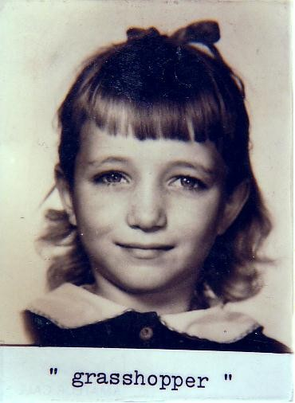

1 May 1941
Henry stands on a lonely Mississippi highway with an overnight bag in one hand and holds up his thumb. He carries a great sadness and decides to join the navy and see the world. It will be a wild ride.

Hitchhiking is a fairly common way to get from place to place. People trust each other more than they will in times to come. It is almost 150 miles from Laurel, Mississippi to New Orleans and if his luck is good he should be at the U.S. Naval Recruiting Office located in the Federal Building on Canal Street by dinner-time.

He had grown up during The Great Depression and had learned the lessons of self reliance at an early age. During the ride south, this healthy country boy feels bullet proof and is able to run all day long like a horse. This self confidence and inner strength will save his life and the lives of his comrades many times during the next four years.

At almost 21 he is in the springtime of his life. On this morning in May the warm sun looks down on the world and sees things that are not yet visible to Americans. Half a world away “apocalyptic horsemen” have already mounted their steeds of conquest and are well on their way toward plunging the world into the most terrible war that has ever taken place.

The tall buildings of New Orleans now come into view on the horizon and it is quite a sight for the country boy. Henry has to walk about five miles through the city to reach the U.S. Naval Recruitment Office where he is sworn in on 5 May 1941. He is tired and hungry and has eight dollars in his wallet.

“When they told us they were going to feed us my eyes lit up and I was glad I had saved my money.”

It is lonely to be in a strange place without friends but the time goes by quickly and three days later he and some other recruits find themselves on a train bound for boot camp at San Diego, California.

“At the time I went through boot camp we had just a small platoon with only about 30 or 35 in the company because there weren’t many people joining. But they did what they could to get us ready for what they knew was inevitably coming.”

After boot camp, he gets a 30 day leave to come home to see his mother. It is the last time he will see her in mortality. She will pass away while he is in battle and he will not learn of it until three months later due to the fact that he is deemed irreplaceable because of his newly acquired knowledge of German radio procedures. After his leave he bids his mother goodbye and reports back to the naval base at San Diego. When he arrives there he is put aboard a ship which steams out to Pearl.

Upon reaching their new base, all of the men are given aptitude tests to help determine how they can best serve. Henry’s IQ indicates that he is suitable for radio school, so he goes to that school for 30 days. During his time in radio school he helps in the apprehension of a man who turns out to be a German spy.

“One day when I was returning to the school from chow, I was approached by a civilian on the road who began asking me questions about the existence of the radio and the RADAR schools. I told him I didn’t know what he was talking about. He was tall and slender with black hair and black eyes. He was dressed in black pants, brown shirt and high top, fancy shoes. Honolulu was full of spies at that time. I hurried back to the school and reported the incident to Shore Patrol. They picked him up as the civilians were leaving the base that afternoon.”

The 30 days in radio school are almost over and graduation is near. Henry graduates and receives his certificate showing that he had passed with flying colors.
As they return from chow shortly after graduation, Henry and his mates stand in front of the radio school looking toward Ford Island and notice a group of airplanes. The planes are practicing quick landings and brief touch downs. Henry states that he would like to get into aviation. The chief who is standing behind him hears him make that statement.

“At that time the U.S. was really searching for people to get into aviation”, Henry recalls.

“Get your sea bag and belongings and come with me”, says the chief.

Henry complies. They get into a jeep and catch a boat over to Ford Island and go to the administration building where Henry announces that he would like to get into aviation.

“Have you had any flying experience?” asks the chief.

“Not hardly”, Henry replies.

“Go down the hall to the 3rd door and completely undress. A doctor will give you a physical from stem to stern”, he is told.

The physical examination includes a depth perception test which he passes and Henry is promptly enrolled into flight school. He is trained as a tail gunner/radio operator.

As he flies over the islands and to the gunnery range he is taught to fire the guns on the airplane, operate his radio and practice sending Morse code messages with light signals.

After a few months of flight training he is assigned briefly to USS Medusa, a fleet repair ship. She is equipped with foundry, blacksmith, electrical, pipe, carpentry, machine, and motion picture shops. Her machinery includes lathes, radial drills, milling, slotting, and boring machines, as well as optical repair apparatus, armature bake ovens, and coil winding machines. To meet additional demands from the fleet, she has large laundry, bakery, and refrigeration units. Her function is to provide major repairs beyond the fighting ship’s own capabilities but which must be accomplished without benefit of a navy yard.

Two weeks later he is reassigned to Gunboat 280 which accompanies a supply ship, a tanker, 6 or 7 destroyers and 4 other gunboats to China. The oriental countries of China and Japan whose people are so different in temperament have been locked in combat since 7 July 1937 when Japan attacked deep into China from its foothold in Manchuria and overran Beijing, Shanghai and Nanking. By 1940, the war had reached a stalemate with both sides making minimal gains. During this time the United States provided heavy financial support to bolster Chinese air forces.

Chapter 3
7 June 1941
Henry has been in the navy for almost three months now. He doesn’t know it but the career of the ship on which he will spend the entire war is also about to begin.

The huge vessel is longer than two football fields. She slides smoothly down off her moorings at the New York Shipbuilding Corporation of Camden, New Jersey into the Delaware River to commence her life as the lead ship of the newly designed South Dakota Class battleships. Exactly six months later Imperial Japan will cowardly bomb Pearl Harbor.

Japanese Adm.Yamamoto will say, “I fear we have awakened a sleeping tiger…”

As a result of her service in helping to turn back enemy advances in the Solomon Islands of the South Pacific Theater USS South Dakota will become the most decorated battleship of World War II. She will be awarded the Navy Unit Commendation and 15 battle stars; a record for all time; before or since. Her official name is BB-57, but for security reasons she will be mysteriously referred to only as “Battleship X”. The Japanese are constantly inventorying the U.S. Fleet and the U.S. Navy is reciprocating. So she will sail without a name or number with the stealth of a shadow. The crew are forbidden to write her real name on anything and diaries and photographs are forbidden. No one but the crew is allowed aboard and the crew does not wear uniforms. When they come ashore and are asked the name of the ship they pretend not to understand the language. Not even high ranking officers can get any information concerning her name or place of origin.

This quotation from a crew member from that period emphasizes this policy of secrecy:

“There is no telling when you will be permitted to learn her name. It may be months, or a year or more hence, when reasons of naval security no longer require the strict secrecy that now is necessary. Or it may not be until the end of the war, when the last Jap ship lies at the bottom of the receptive Pacific or has sneaked back to whatever may be left of the place called Tokyo.”

Battleship X is painted black so that she can prowl the seas with her lights out at night with an uncanny cloak of invisibility. The crew will be hand picked for their competence. Henry Stewart will become the Captain’s Morse code radio operator during battle stations.

A battleship is any one of a class of warships of the largest size, carrying the greatest number of weapons and clad with the heaviest armor. Ships are euphemistically referred to as being of the feminine gender and in some mystical way they can be as protective of their crew as a mother lion is of her young – majestic and beautiful in her accoutrements yet fierce in combat. Battleship X will be such a ship. Her mission will ultimately be to lead her sister ships in the protection of the fleet and more specifically to protect the aircraft carrier USS Enterprise in the battles of the South Pacific.

Her cubs consist of 1250 men including officers and she can sprint at a speed of almost 40 knots, enabling her to literally run circles around anything else afloat. A 12 inch suit of armor clothes her exterior and her fire power is awesome. She is large, having a 35,000 ton displacement and deep within her bowels a 6,950 ton fuel oil tank feeds 8 boilers. They in turn power the turbine engine delivering 130,000 horsepower to the four screws. Her 16 inch guns can hurl ten tons of metal at a target twenty miles away with surgical accuracy due to RADAR sighting and no one is allowed on deck when the guns roar because the vacuum produced can literally suck a man out to sea trailing the shell. Henry will be trapped on deck in one such instance after the doors are locked and he has to hold on for dear life.
“My ears rang for 2 weeks after that”.

She will prove to be able to absorb punishment like a killer whale shrugging off the nip of a sardine. These are some of the technical details that delineate her anatomy, but they do not begin to touch her soul if a battleship can be said to have a soul. Suffice it to say she certainly has a destiny.

November 25, 1941 aboard the flagship HIJMS Nagato
Japanese Adm. Yamamoto sends a radio message to the group of Japanese warships that will attack Pearl Harbor on 7 December 1941. Some 65 years later in his book Day of Deceit, Robert Stinnett, who serves in the U.S. Navy under Lt. George H.W. Bush, by virtue of what shall come to be called The Freedom of Information Act will examine declassified American government documents and conclude that far more than merely knowing of the Japanese plan to bomb Pearl Harbor, Roosevelt deliberately steers Japan into war with America. His military and State Department leaders are at this time agreeing in declassified memoranda that a victorious Nazi Germany will threaten the national security of the United States. Documents will show that in White House meetings the strong feeling is that America needs a call to action to override current domestic isolationism regarding America’s entry into the foreign war. The declassified naval records will further prove that from 17 November 1941 to 25 November 1941 the United States Navy intercepts and decodes 83 messages that Yamamoto sends to his carriers.

Part of the decoded November 25th message reads:

"Climb Mount Niitaka on 12/08 (Tokyo time). “ This is a code within a code. The prearranged meaning is: ‘the task force, keeping its movements strictly secret and maintaining close guard against submarines and aircraft, shall advance into Hawaiian waters, and upon the very opening of hostilities shall attack the main force of the United States fleet in Hawaii and deal it a mortal blow …’ ”.

An adopted child, Isoroku Yamamoto, now 57 years old is a full admiral in the Japanese Imperial Navy. Unlike most of his comrades he speaks English, having studied in America. He graduated from Harvard University in 1921 and is familiar with the strengths and weaknesses of the United States. After graduation, Yamamoto returns to Japan, joins its navy and having specialized in the new field of military aviation has risen rapidly through the ranks. Although his opinion of the U.S. Navy is low, having described it as “a club of golfers and bridge players”, he is fully aware of the power of the United States as a nation.

Adm. Yamamoto has become a driving force in the development of Japan's aircraft carrier force and in making it his navy's spearhead. His demands have led to the development of Japan's carrier-launched fighter, the Zero, and other excellent aircraft. Additionally, the Japanese Imperial Navy is equipped with the world's fastest, most powerful and most efficient torpedoes capable of being deployed from both submarine and aircraft.

Despite his military prowess, Yamamoto is a prudent man. From his office in Tokyo as Vice Minister of the Navy he strongly and consistently opposed those in his country who wanted to go to war. But in the late 1930s Japan is so extremely militarist that in 1939 a plot to murder Yamamoto is uncovered owing to his opposition to war. In order to protect him from being assassinated by the extremists in Tokyo, he is sent back to sea as commander of the Combined Fleet, a mighty armada which includes practically the entire force of the navy. Before his departure, Prime Minister Prince Konoe, Tojo’s predecessor, asks Yamamoto about Japan's chances in a war against the United States and Great Britain.

Yamamoto’s answer: "We can run wild for six months or a year, but after that I have utterly no confidence. I hope you will try to avoid war with America".
His prophecy will later prove to be correct!

26 November 1941 – Domestic intrigue
In the USA, Japanese spies are busily engaged in establishing an intelligence network. An FBI report for this date documents the payment of $25,000 to Mrs. Velvalee Dickinson, owner and manager of a doll shop at 718 Madison Avenue in New York City. She uses correspondence about dolls to conceal information about U.S. Naval forces she is attempting to convey to the Japanese via South America. The payoff is made by Japanese Naval Attaché Ichiro Yokoyama then stationed in Washington D.C. He will later be promoted to Rear Admiral in the Imperial Japanese Navy. At war’s end he will be arrested by Henry Stewart as the “big fish” aboard the battleship Nagato berthed in Tokyo Bay.
When confronted with the evidence against her, Mrs. Dickinson, a former member of the Japan-American Society will eventually plead guilty to the censorship violation, and will promise to furnish information in her possession concerning Japanese intelligence activities. Her sources of information are through questioning innocent and unwitting citizens in the Seattle area around the Bremerton Navy Yard, the Mare Island Navy Yard in San Francisco, and from personal observation. She states that “open coded” letters are used to transmit information about aircraft carriers and battleships damaged at Pearl Harbor, and that names of the dolls appearing in the letters referred to these types of vessels. She is imprisoned and fined.

Chapter 4
Early December 1941
The small flotilla of which Henry is a part arrives in China and his gunboat steams up the Yangtze River for a distance of about 200 miles. They are making port calls when a Catalina PBY arrives with startling news!

7 December 1941
The sunny, peaceful Sunday morning lies in sharp contrast to what will happen a little later on. The two signalmen study the new equipment which is largely regarded as a laboratory curiosity. It is called RADAR, an acronym for Radio Detection and Ranging.
Suddenly the RADAR screen lights up. Is it an equipment malfunction? The men report the unusual appearance to the duty officer and they are told to disregard it. By the time visual confirmation is made it is virtually too late to do anything about it.

The two signalmen, Joe Lockard and George Elliott, operating an SCR-270 RADAR set, have seen approximately 300 Japanese fighter planes approaching as early as 7:02 A.M. on this Sunday morning. They check their equipment. They have not ever seen such a large signal presentation before. At 7:20 A.M. they telephone the sighting to the Information Center. The information is not acted upon and the first bombs fall at 7:55 A.M. Over fifty minutes are lost. Victory could have been taken from the attackers and American lives, ships and aircraft protected.

1st Lt. Harold Zahl has one burning worry:

"Has our early-warning RADAR failed?"

He is a physicist and for years, under great secrecy has been part of a group working to prevent a surprise attack. How could the Japanese Empire achieve such complete surprise? After an enemy flyer radios the now famous Tora-Tora-Tora, (Tiger-Tiger-Tiger) code words 2,400 Americans are killed, and the American Pacific Fleet is heavily damaged; 18 U.S. warships and 150 aircraft, as Japan cowardly bombs Pearl Harbor. The intensity and devastation of the air attack are beyond description. It is the day that hell came from the sky. It will be answered many times over some four years later when the American birds drops their eggs from the sky.

It will be a day that the world will never forget and the devastation will be horrible, but due to Japanese fanaticism it will be the only recourse to terminate the war.

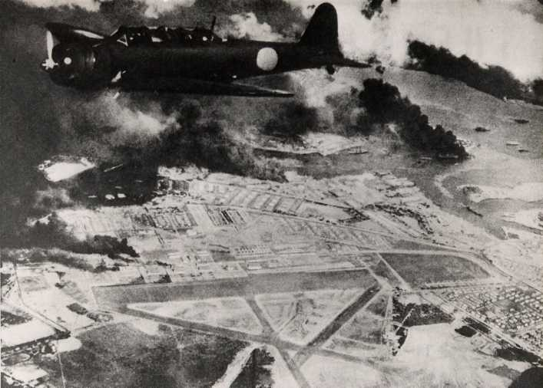

Captured Japanese Propaganda photograph. The caption reads "Pearl Harbor in flame and smoke, gasping helplessly under the severe pounding of our Sea Eagles."

The next day President Roosevelt makes his famous speech to Congress: “Yesterday, December 7, 1941—a date which will live in infamy—the United States of American was suddenly and deliberately attacked by naval and air forces of the Empire of Japan.”

The speech is passionately convincing as the president speaks with pretended alarm. He asks for and receives a declaration of war against Japan the same day. America, who has derisively been called isolationist because she wanted no part in foreign wars, has now received her call to action. Patriotic enlistments boom. Who can refuse to join the Allied Forces now?

Aboard Gunboat 280 on the Yangtse River
Henry and the rest of the crew are ordered to promptly come aboard the PBY because Pearl Harbor has been viciously attacked! They comply and the 1st Lt. who is the captain of the gunboat scuttles it to keep it from falling into enemy hands. The crew is flown to Australia where they are put up in a hotel for about four days before getting orders to report to the docks and board the submarine USS Squid, which transports them back to Pearl Harbor.

When they arrive at Pearl, the oil on the water is still burning. On high alert, the U.S. Navy is hesitant about letting the Squid into the harbor because of the fear of enemy submarines which might be present. It takes about four hours to get them to open the net. When they get on shore they are assigned to begin cleaning up the mess created by the Japanese attack.

At this time Henry and seven of his mates are able to persuade a PBY pilot, to take off so that they can see the damage and take some photographs from the air. Henry still has these original photos and some of them are produced below. The PBY is the only plane that can fly, as it has been stationed at Ford Island in the middle of the harbor and has thus not been damaged. Jap Zeros are still flying around in the air like angry bees. In fact one of the enemy pilots sees Henry taking pictures of it and begins firing at him with its 30 caliber machine guns. He takes cover behind some empty oil drums.

As the weeks pass and America mobilizes for war, a national sense of frustration persists while President Roosevelt and his military leaders try to figure out how to retaliate quickly against a distant and powerful enemy. Some memorable response is deemed necessary in order to bolster the national will.

February 1942
Task Force 16 is formed around the carrier Enterprise, Adm. “Bull” Halsey’s flagship. The task force consists of 17 ships; mostly cruisers and destroyers and its first mission is to shell Wake and Marcus Islands located in the middle of the Pacific Ocean, about 2,200 miles west of Honolulu.

Following the shelling of these islands TF16 moves northeast and takes up a position approximately 500 miles east of Japan and waits. Henry and his mates are thankful for the brief reprieve from combat however they wonder what they are waiting for. Unbeknownst to them, a top-secret mission is already underway which will prove to be one of the most daringly famous of the whole war. For the present Henry is content to gaze out at the sea which he has come to love and contemplate his new career.

Vice Adm. William F. Halsey, Jr., a graduate of the U.S. Naval Academy serves as fleet commander. Toward the end of the war he will be promoted to five star admiral. His motto is "hit hard, hit fast, hit often." He is approximately the same age as his Japanese nemesis, Adm. Isoroku Yamamoto. Both men are strong advocates of carrier warfare and have both had extensive training in the new field of military aviation. They are pretty evenly matched.

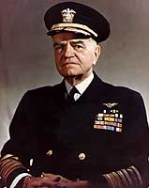
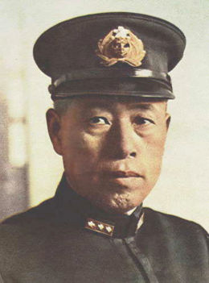

Adm. William Halsey Adm. Isoroku Yamamoto

Chapter 5
1 April 1942
At the highest levels of the U.S. Government, the retaliation has finally been identified. Following two months of intensive training and acting under top-secret orders, U.S. Lt. Col. Jimmy Doolittle organizes 16 highly modified B-25B medium bombers, their five-man volunteer crews, and maintenance personnel. They train for short take offs at Eglin Field in Florida before they fly to the west coast. There, they are loaded onto the deck of the largest aircraft carrier USS Hornet at Alameda, California and are designated Task Force 18. Included are the Hornet, Vincennes, Nashville, Gwin, Grayson, Meredith, Monssen and Cimarron. A few weeks later they will rendezvous with Task Force 16, composed of Adm. “Bull” Halsey’s flagship, the carrier USS Enterprise and its escort of 16 additional ships consisting of cruisers and destroyers north of Hawaii. This is what Henry and his mates have been waiting for. They watch the approach of Task Force 18 and observe that it becomes a part of their own TF 16.

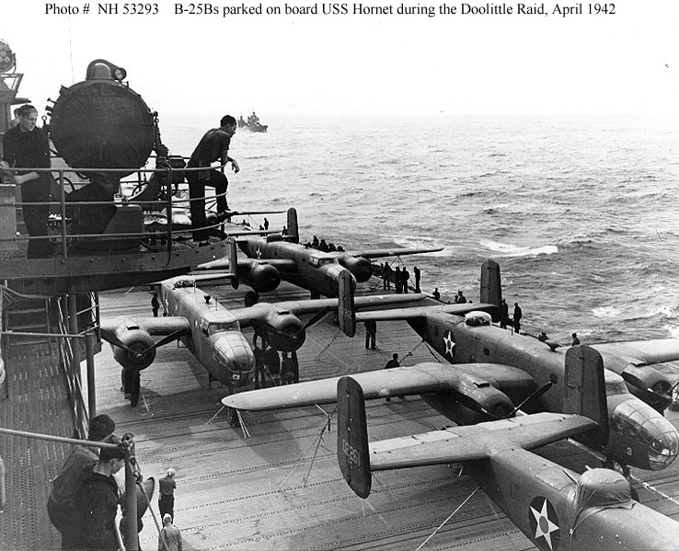
Lt. Col. Jimmy Doolittle’s Raiders

The bomber group launches 650 miles east of the target from the pitching deck of USS Hornet amidst a storm and flies deep into Japanese territory. Encountering light defense they bomb the strategic objective: Tokyo, on 18 April 1942. The enemy has been taken completely by surprise. The Hornet is not large enough for the bombers to return and land on, nor could the bombers sustain such an abrupt landing, so as per prearranged plans Doolittle’s Rangers head for the China coast. The B-25’s crews hope to land on secure fields in China. It is a vain hope.

The fields do not respond to radio inquires, as they have been overrun by the Japanese. The bomber crews have to bail out and ditch their aircraft over enemy territory in occupied China. With the help of the Chinese underground, Doolittle and his crew painfully make their way to the rural village of Chuchow. Many of their comrades are not so lucky and are either killed on impact, captured and tortured by the enemy or land in Russia where they are imprisoned. The exchange which follows is of course unknown to the men of TF16 who hope and pray that the mission has gone well.

While Doolittle and his crew are hiding in a sampan near the small village, a young man, dressed as a coolie stops on his river journey back through the dangerous area to eat at a humble restaurant. A member of the underground comes and sits at his table and speaks these words to him in Mandarin:
“If you are an American, follow me.”

After making sure he is not being observed he follows the man outside and is led to the sampan. He then makes contact with Doolittle’s crew and subsequently leads them out of enemy territory to safety. He turns out to be the missionary John M. Birch. This experience leads Col. Doolittle to recommend Birch to Gen. Chennault, who has rejoined the U.S Army. On Doolittle’s recommendation, Birch is offered a commission in the U.S. Army. He is later promoted to Captain.

Often operating behind enemy lines, John organizes Gen. Chennault’s intelligence network, personally going into hostile territory and directing Allied bombers to hidden Japanese targets and enlisting the support of the Chinese in the rapid building of landing fields. Following the war, Capt. Birch will be brutally murdered by Chinese Communists whose motives he will try to determine on behalf of the U.S. Army. The story of his murder will be covered up by the U.S. State Department in the interest of promoting acceptance of the new Mao Tze Tung regime and the disarming of Nationalist China by U.S. Sec. of War, George Marshall, thus forcing them to withdraw to Formosa.

Chapter 6

Battleship X
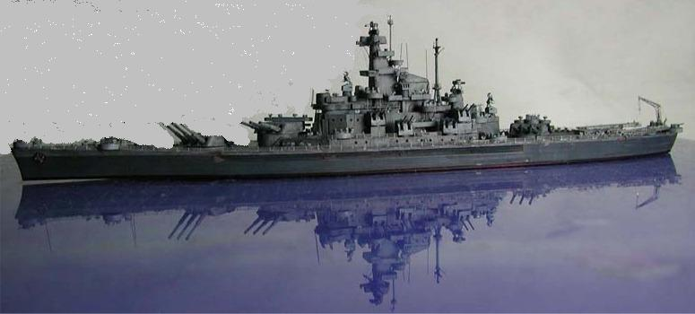

16 August 1942
Battleship X begins her first war cruise with Capt. Thomas Leigh Gatch in command and crosses from the Atlantic to the Pacific Ocean on 21 August 1942. Gatch is a slender man with black hair and black eyes. A 1912 graduate of the Naval Academy he has already spent more than half of his life in the navy. He will distinguish himself three months hence at the battles of Santa Cruz and Guadalcanal. He is 51 years old and will come to be much admired and loved by the crew. He is an excellent warrior and leader.

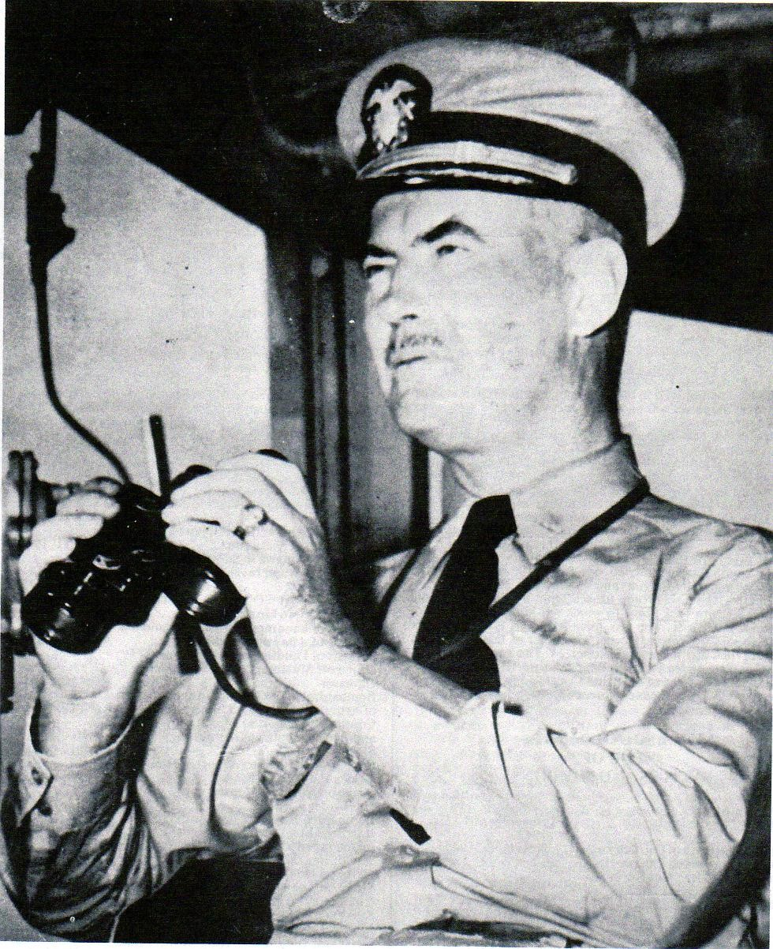
Capt. Thomas L. Gatch
The big ship’s movement through the Panama Canal is tedious. The transit time to change oceans will be about eight hours. Due to her size there is less than one foot of clearance on each side. The crew has to stand clear due to the tight fit. At times, with no warning, shrapnel-like bursts of concrete fly over the deck as the ship grates the sides of the canal. She emerges at day’s end and steams for the Tongan islands in the South Pacific where she arrives two weeks later.

Upon arrival, an unexpected collusion with an uncharted coral reef pinnacle in Lahai Passage causes extensive underwater damage to her hull, necessitating repairs at Pearl Harbor.

22 September 1942
Battleship X arrives at Pearl for dry dock repairs. All present gaze upon her with undisguised pride and high expectation and hope following the vast destruction that occurred there the previous December. All present at Pearl Harbor are in formal dress whites with bands and crews standing at attention to see this new “Queen of the Fleet” arrive. Everyone present knows there is something special about this large black ship with no name.

During the repair period, Capt. Gatch has additional guns installed on every available spot including a quadruple 40 mm gun emplacement on the bow. Battleship X is the only battleship with such an installation. He even wants to remove the catapults and the pontooned Kingfisher scout planes, known among the crew as “Lame Ducks” but Adm. Nimitz will not approve the request. The effort of bringing the crew up to a level of 1250 men now begins in earnest.

It is during this period that Henry is hand-picked for duty on the big ship due no doubt to a favorable recommendation from the chief at the radio school he has recently graduated from. He is approached by the radio chief from Battleship X and asked to demonstrate his speed key proficiency.

“Is this your top speed?” the chief asks.

“No sir, I can do about 40 words per minute with a little practice”.

This Morse code speed is faster than the chief can do. Henry is then recruited to become part of the crew. The paths of this gentle man and the remarkable ship have now become the same and will not be separated until war’s end.

“Bull” Halsey has chosen Battleship X as his flagship because he needs security and she is the best that they have. Henry’s life as a radio man is anything but dull, especially during combat. Many times after serving a shift on General Quarters (battle status) he attempts to get some sleep, only to be awakened and ordered to report to Radio 1 to clear traffic. Radio 1 is three decks down and is all cryptographic. Armed Marines guard the decoding machines. The communications officer decrypts the encoded messages with these machines. Most of the messages are from the Naval Radio Station (MPM) in Honolulu and are deployment orders for Battleship X and the vessels which she shepherds and protects.

During his spare time Henry copies Associated Press News for the ship’s newspaper. Radio Central is his usual workplace and this is where the asbestos-wrapped steam lines run. It will be years later before he develops Asbestosis as a result of breathing the harmful particles of asbestos.
He also has a battle station up in the super structure in Con 2. This provides a redundant helm from which the Executive Officer who is second in command can operate the ship in an emergency. And of course the presence of Henry’s radios will be essential in such an instance.

The radios in Con 2 are normally locked up, however during drills, Henry enables them and steers the fleet using encoded English phrases.

Chapter 7
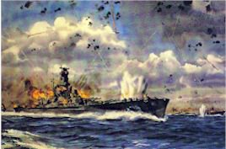
25 October 1942 - The Battle of Santa Cruz.
Henry closes his eyes and remembers: “It was primarily an air battle. They came at us at daylight; land based planes – wing tip to wing tip, from aircraft carriers and any place that they could launch from. They attacked our task force – all day long. We fought off wave after wave for 12 hours and preserved the carrier Enterprise. We shot down 38 enemy aircraft at Santa Cruz. Only one bomber got through and placed a 500 pound bomb on our #3 turret. Capt. Gatch refused to take cover. He said he wouldn’t ‘duck for any damned bomber’ and was seriously injured from shrapnel wounds.

“The Jap fighter planes would come in first and strafe the decks trying to kill all of our gunners so that we wouldn’t be able to shoot down the bombers which followed.

“The captain’s juggler vein was severed and if it hadn’t been for the immediate availability of a corpsman who stopped the bleeding he would have lost his life. After the bleeding was stopped Capt. Gatch went back on duty with his arm and neck immobilized. His arm had to be positioned over his head due to the nature of the neck wound. Even with this injury, Capt. Gatch personally continued to steer the ship during the remainder of the battle and also during the Battle of Guadalcanal which followed. For the next two years he didn’t have the use of his left arm.

“Our captain was worshipped by the crew. He was one of the finest men who ever walked.

“At one point in the battle, nine Kate torpedo planes came at us from quite a distance in single file. They were determined to get us. Our U.S. Hellcat fighter, also know as the Aluminum Tank continually swooped down from 16,000 feet and blasted each one out of the sky beginning with the last and proceeding to the first. It was like shooting turkeys. Not a single one out of that group got through.

“We got a dispatch from the navy that a large convoy of Japanese ships was converging on Guadalcanal and we were ordered north to intercept it.”

The following story is both heartbreakingly heroic and demonstrates what can be done when one has no alternative.

“Our OS2U Kingfisher planes were used to perform life guard duty, picking up downed pilots. We were dispatched to pick up a two man fighter crew from the Enterprise near Savo Island.

“One of our planes was let down into the water and we took off in the smooth wake which was left by the ship as she maneuvered at an oblique angle. It didn’t take us long to spot the wreckage. It was floating about a mile from Savo Island.

“After Lt. Robie landed, I got out on the wing and tried my best to pull the surviving injured man up on the wing but he was so badly injured that he was dead weight. Although I was tall, I only weighed about 110 pounds at that time and I wasn’t strong enough to get him up by myself and so my pilot disobeyed protocol and joined me on the wing. We could hear machine gun fire from the island but tried to ignore it. And then a bullet found its mark and Robie fell into the sea. I dived for him over and over again but I couldn’t find him.

“I told the injured man, ‘Now you’re going to have to help me or I’ll have to leave you here’. Somehow, with his feeble help I got him up on the wing. I tied his hands to one wing stanchion with my belt and tied his ankles to the other stanchion using his own belt.”

Henry climbs into the front cockpit and takes off. Suddenly, he realizes that he doesn’t know which way to go. He needs guidance and the radio is in the rear cockpit. He levels off, places the aircraft on autopilot and climbs back to the rear seat almost falling out in the process. Next, he buckles his seat belt, hooks the radio to his helmet and attaches the throat mike. He then contacts Battleship X and requests a radio beacon.

“The radio chief on the ship told me that they could only supply the beacon for one minute so as to avoid making themselves a target. The one foot loop antenna had to be turned to get the minimum and maximum signal strength in order to utilize the beacon. The antenna had calibrated compass readings. I performed the necessary calculation to get the plane turned just as the beacon went off. I had initially been headed in the wrong direction.

“I could easily identify our ship by the 40 mm guns on the bow. When the ship again executed her oblique turn to create the smooth water wake, I made my final approach passing about ten feet over the bow. The men on deck ducked. I came in a little too low, went right through a 20 foot wave and almost drowned the pilot. The plane bounced around a little but didn’t turn over. They sent a motor whale boat out, fired the engine up and winched the plane back up on the starboard catapult. Men swarmed all over the plane examining it for damage. Before I could get out of the cockpit a corpsman injected a sedative into my arm.”

“You’ll want to get on the stretcher in a minute because you’re going to sleep now.”

Henry wakes up in sick bay where he remains for about three days; still scared.

“After I recovered and was released, I went back down to sick bay to check on the fighter pilot. He was on a very low bed. He had asked the male nurse where the man was who had rescued him.

“The pilot asked me, ‘Are you him; the man that brought me in here? I’ll have you know you almost drowned me. I thought I was a dead man 100 times on the way in.”

The two men then sit and talk over cookies and milk. The navy sends a DE (Destroyer Escort) into the harbor to look for Lt. Robie but never find him. He had been a school teacher from West Virginia.

It was a hair-raising experience and Henry received a Presidential Citation from FDR for his heroic action. In addition to this he will ultimately be awarded 15 battle stars attached to the ribbons on the following medals: United States Navy Medal, American Campaign Medal, Solomon Islands Medal, Asiatic Pacific Medal, Victory Medal, Guadalcanal Medal, Silver Star Medal (for the Philippine reconnaissance mission), Philippine Invasion Medal, European African Eastern Campaign Medal, Good Conduct Medal, Antarctic Circle Medal and the Naval Academy lapel pin (from radio school),

Chapter 8
12 November 1942 - The Battle of Guadalcanal
Seven days after the Battle of Santa Cruz Battleship X engages the enemy at Guadalcanal and is opposed by the whole Japanese Imperial fleet. Capt. Gatch, although still injured is in command. During the course of the fight “Old Nameless” sinks 24 enemy transports loaded with Japanese troops and a supply ship carrying ammunition.

Henry closes his eyes and remembers: “We pulled into Sea Lark Channel, north of Australia and south of Savo Island and we set a trap for the Japanese and they fell for it. We contacted the battleship Washington, the flag ship of Adm. Lee, the commander of our battleship squadron and told him we had acquired two targets. The order ‘Open Fire when ready!' was received. We went to battle one minute after midnight. Our ship fired three salvos at one time. We hit an enemy supply ship and it went 500 feet into the air, broke half in two and sunk in just a matter of minutes. Then we turned our attention to the other Japanese ships. We were doing figure eights through their fleet steaming at near full speed and firing at all of them at the same time. It was bedlam. We were close enough to the enemy barges that we could hear them hollering. Before retiring from battle we had set a record.

“Shortly after the battle started, the enemy illuminated our ship with powerful spotlights from a cruiser. We knocked them out quickly but that had allowed the enemy to visually mark our position and we took quite a few direct hits as a result.

“The Japanese intentions were to reinforce Guadalcanal the next morning at daylight. We sank a cruiser, nine destroyers, a battleship and a frigate before retiring from the battle. The Washington, the lead ship in our force had left us; they thought we were dead in the water. Battleship X was burning and they thought we were dead in the water and they went off and left us.

“I heard something and looking up I saw a Jap Kate (so called by Allied command) and he was coming straight down at us. I figured that he intended on putting a 500 pounder right down our stack. I wrapped myself around the flag pole and held on for dear life. The bomb missed me by about two feet and killed all of the firefighters on a lower deck.

“The fighting had been very intense and we suffered a lot of casualties. I have the terrible memory of coming upon a man who had both legs blown off at the hips and massive internal injuries. In his agony he begged me to throw him over the side. I couldn’t do it. He begged me to shoot him with my 45 to put him out of his misery but I couldn’t do that either. I knelt down beside him and held his hand till he died. His pulse just grew weaker and weaker.

“Our ship was on fire from one end to the other. We had taken 48 direct shell hits from gunfire during this battle. The deck was melting out from under us, so me and the Executive Officer decided to leave our battle stations, which were useless and go to find a machine gun that we could use to fire at the enemy.

“When we left our battle stations, I attempted to take my usual route down a ladder on the front of the super structure. It was pitch black dark that night – no stars. Unbeknownst to me the ladder had been blown away and when I jumped for it, I fell about 25 feet onto the steel deck.”

The fall breaks a bone in Henry’s back which was never attended to and which hurts him the rest of his life. He is knocked unconscious and is assumed to be dead. His body is placed in a large pile of corpses in the shack usually occupied by the Officer of the Day. It is an empty room which is being used as a temporary morgue to hold the bodies until they can be buried at sea.

And then a miraculous thing happens: A corpsman with a little red light happens to shine his light on Henry’s foot as he passes through the room of the dead. Henry’s foot moves. The corpsman finds a pulse and gets him out of the pile and down to sick bay.

“I woke up in sick bay three days later. The doctor handed ma a little shaving mirror and told me to take a look at myself. I couldn’t see anything wrong with my face, but my hair had turned white. It surprised the daylights out of me and the doctor couldn’t explain it to me either.”

Before falling, Henry sees two U.S. destroyers, USS Preston and USS Walke. Both U.S. destroyers are accidentally sunk by friendly fire from the Washington when she acquires the wrong targets. Current official U.S. Naval history denies this.

Henry is told by the Executive Officer, Commander A.E. Uehlinger, “You didn’t see that did you son?”

“No Sir”, Henry replies.

It is a secret that will haunt him the rest of his life. He tries to tell a fellow radio man, but he doesn’t want to hear it. In his frustration, anger and desire for justice he writes the following letter some 63 years later:

“To: The Navy Department Ref: The Sinking of the Japanese
Washington, D.C. Krishima and the loss of
United States ships “Preston”
and “Walke”.

“GUADALCANAL”
1942

“My name is Henry Stewart. I was a crew member of the United States ship South Dakota for four years. My rank was Radioman 2/C. I was CDR. Archibald E. Uehlinger’s Radioman. Our battle stations were high up in the super structure in second con. Our view was perfect.

“This is the truth, and the way it all happened, if you care to know the truth, we were there.

“Our task was running interference for a fast Carrier, the USS. Enterprise. This novel assignment for a battleship produced the Battle of Santa Cruz on October twenty-six wherein we preserved the carrier from the heaviest air attack ever visited upon a batttlewagon, shooting down at least 38 Jap aircraft. The taste of victory was sweet with officers and men of our ship, which cannot as yet be named for security reasons, as we hauled off to the southwest. The captain had shrapnel wounds in his neck received at Santa Cruz, and recovered promptly, but his arm had to be put into a sling.

“The officers, many of them reservists, and the crew, 60 per cent boots, were honing for action after Santa Cruz, but spoiling as they were for a fight, I doubt if any foresaw the truth; that fact was without precedent. No other American battleship ever having fought twice within that brief span of time, it helped give our great ship its reputation, as phrased by leading officers as being “One of the most extraordinary battleships in American History.

“We were ordered north in response to reports that heavy enemy concentrations were moving toward Guadalcanal from the north and northwest. On the night of November twelfth-thirteen, the enemy had made a stab in force toward Guadalcanal. That was the night Rear Adm. Norman Scott and Rear Adm. Daniel Callaghan lost their lives and the cruiser San Francisco led a gallant column against superior forces. We won the action, turning the enemy back.

“Our outfit arrived on the third night, whipping up after sundown from a rendezvous out of sight of Jap observers on Guadalcanal. Our own air scouts reported that the ‘Nips’ forces moving south that afternoon contained two battleships, eight to ten cruisers, a great number of destroyers and more than twenty transports. The numerical odds were plenty long against us. It seemed possible and this we hoped that the enemy commanders believed he had disposed of whatever formidably United States strength might be in the vicinity and had now only to fight his way through a thin line and land his troops on Guadalcanal. We asked only a slight advantage of surprise to help even up the enemy’s strength in ships. As it turned out, we did have some luck, but luck in war is always earned.
“Guadalcanal, running east and west, forms one side of a ‘V’ with Florida Island. Adm. Lee, who was on the Washington skillfully baited a trap. We had swept up to the west of Guadalcanal and we held our course northward until we passed Savo on our starboard. It was a pitch black night. Off in the northwest were gun flashes, indicating that some of our forces, surface or air, were attacking the transports.

“Passing Savo, we headed southeast toward Henderson Field, traversing the ‘V’ having seen neither hide nor hair of the enemy thus far. We slowed down so as not to be too early at the meeting place appointed by ourselves and we began reproaching the enemy inwardly for keeping us waiting. Although a trained fighting man likes combat for itself, the real joy is in quick and conclusive victory.

“The Japs, however, were not very late, and as we headed out toward the open sea between Savo Island and Esperance our observers spied them. Strange ships were apparent to the east, south of Savo. The Japs had been following us around Savo, but they seemed unaware of our presence. We reported by radio to the admiral and the answer came back, ‘Fire when you are ready.’

“Our first two salvos hit both targets. An orange glow appeared in the center of each. Black smoke rose and soon one of them burst into leaping flames.

“Before sighting this formation, radio operators had identified 13 enemy talkers and I could almost swear one was a woman, since some of the talkers were no doubt ashore in the Jap installations on Guadalcanal.

“At 2252 hours: we changed course to (270). At 2316 hours we opened fire and sank the AYANAMI. At 2320 hours we had a power failure. We lost all power, a multibraker switch tripped. At 2333 hours all power was restored. At the time of the power outage, CDR. Uehlinger and I saw the “Washington” open fire to her starboard, the USS Preston a destroyer was hit and burning, and to us it looked as if the Washington’s fire had caused the accident. I was told by Commander Uehlinger to forget what we just saw. The next day I told a friend in my division, Frank Romanek about what happened. He said, “You didn’t tell me that.” That was his advice to me.

“At 2345 hours we were firing constantly: rounds of sixteens and five inches. Some sank the USS Walke DD on Washington’s starboard side. At 2358 hours Washington changed course to 270 degrees.

“At 2400 hours: South Dakota changed course to 180 degrees and opened fire with three Jolly Roger shells, sixteen inch guns hitting the Kirishma, a Jap battleship. The ship exploded as the shells hit her at the water line amidships. The magazines exploded and it went five hundred feet into the air.

“The South Dakota tried to reach the Washington by radio, as we were burning bad
from forty eight shell hits in our super structure. We heard nothing from Washington. She left us burning, with many of the crew dead. The ship fire and shore batteries had done much damage to the South Dakota. As we retired from the battle we had sank 24 barges loaded with troops, a cruiser, three destroyers and a battlewagon.

“We changed course to 180 degrees with the Benham DD off our port beam. Where was the Washington? Somewhere to the west of Savo Island, alone. She had no destroyer escort screen with her.

“This is the true way that it happened. If it hurts anyone, I am deeply sorry, but it is time the truth came out. I have told no one for fifty years. I hope this will correct a wrong that has been done to Battleship X and its crew: the South Dakota.

Sincerely;
Henry Stewart, Radioman Second Class C.R. Div.
(Letter posted 2005; editor’s note). USS. South Dakota crewman

The Navy Department courteously answers his letter and informs him that it will be placed in the Naval Archives. Henry no longer has this reply.

He continues the story: “The USS South Dakota became the most decorated ship in the navy and still holds that title, nor has any other ship come close to accomplishing her performance. We had taken 48 direct shell hits in our super structure. The Washington saw that we were on fire and considered us lost. They headed west toward Guadalcanal leaving all of her escorts and wound up 300 miles to the west alone without any protection from the subs. Battleship X then headed south with two destroyers; one on each side.

“We steamed toward Australia for repairs. Suddenly, the bridge reported sighting approximately 300 Japanese fighter planes flying in formation toward us and the captain ordered our flag taken down. The Japanese came right down on the water and flew along side of us for a long way, waving their wings as though we were a Japanese ship trying to get back to port. Then they gained altitude and continued flying and never looked our way again. They could have sunk us easy. We had no RADAR, electricity nor radios from the shelling received during the battle. We finally reached Australia for repairs. It was deemed prudent by the navy that the Washington put into New Zealand for repairs. After what had happened it was not considered wise to bring both ships into the same port. The score was settled at the conclusion of the war when the crews of both ships met and fought each other in San Francisco Bay. I didn’t take part in the melee.

“We had entered the Battle of Guadalcanal with 1250 men. After the battle there were only 250 still alive. We had lost 1000 men. I am thankful to have been found among the living. We buried the dead at sea all of the next day. They were each placed in specially made canvas sacks with a five inch shell between their legs do that they wouldn’t float and then they were slid down a table off the fantail and committed to the deep.

“When we got to Australia, they washed down the ship, steam cleaned it and everything they could think of but they could never get rid of that smell of death.”

After the battle Capt. Gatch is assigned to shore duty and a change of command takes place. Capt. McDonald assumes command but he can never take Gatch’s place in the hearts of the crew who actually weep when their beloved captain leaves the ship. When brave men fight together in a great cause they bond in a special way. They become as brothers.

As Capt. Gatch prepares to walk down the gang plank he turns and looks at the crew and they can see tears running down his cheeks. He has expressed his pride and appreciation to this group of country boys on several occasions and it is a tender moment. He knows he will never see them again. Following this change of command, morale suffers and the men “sort of lose their fighting spirit”.

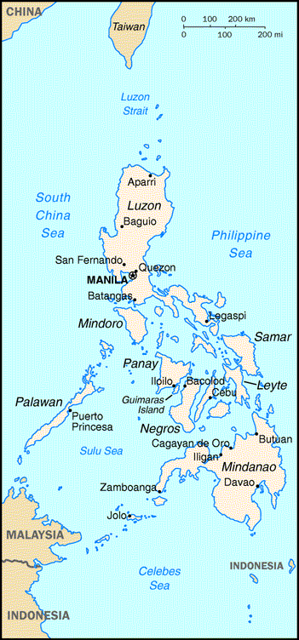
Chapter 9

The Philippine Expedition – November 1942
“While we were in Australia, Gen. MacArthur
asked for three volunteers to go on a reconnaissance
expedition to the Philippines to learn the fate of
Allied pilots who had been shot down there and
captured. Two marines and I raised our hands.
Halsey told me that it would probably be a one way
trip. We made up our minds that we were going and
we were sent to the sub base and we steamed for
the Philippines. They issued us black uniforms. We
got to our destination and the sub put us off in a
rubber boat just a few yards from the shore of
Mindanao Island. Williams had the maps and
compass and he was supposed to be the navigator
and get us back a week later. I was the oldest and
was the designated leader.

“We walked and ran through the jungle going
northwest for what seemed like forever. Just
after midnight a couple of days later, we saw this
big fire. We worked our way through the jungle so
that we could get a better view of what was going on.
We observed Japanese and Philippinoes mixed and they Philippine Islands
had five U.S. Army pilots. They had beheaded twp of them already. I told Scott to get some pictures with his night camera and let’s get out of there because we couldn’t help those people. We would just wind up where they were. That was a hard thing to do knowing what was coming. I thought several times about setting up a diversion to try and draw attention away from the pilots but I knew it wouldn’t work.

“We left heading southeast and ran about 65 miles down the beach. We were literally running for our lives. We stopped to drink some water and eat some K rations. That’s when Scott got killed. His camera was hanging around his neck. I was looking at him when he got it. His whole jaw just disappeared after being hit by sniper fire. We had evidently been pursued by the enemy. I saw Williams run in the opposite direction from where I was sitting. I rolled backward down a little hill and got to my feet, firing my 45 into the jungle. I tried to overtake Williams, but I never did find him anymore and I was left alone. I ran out of water eventually and I happened up on a Japanese barge that was beached and deserted. I sat and looked at it from the cover of the jungle for hours wondering what I ought to do.

“Finally I ran to it and found a Japanese helmet and it was full of rain water. I filled my two canteens after dropping a pellet in it to purify the water. I got back into the jungle so that I wouldn’t be detected and caught. I ate what fruit I could find in the jungle in order to save my K rations.

“One morning just after waking up I heard voices and I didn’t know who it could be. I got behind a huge coconut tree and when the party came through the jungle traveling on an animal trail, they came right by me. The first man was black and had a machete. The second black man had a box on his head and one under each arm. The next man was white and had a big straw hat on. I reached out and grabbed him around the neck and placed my 45 behind his neck.

“I whispered, ‘I’d better hear some English or I’m gonna blow your head off’ ”.

“He let out a scream and I found out that he was an Australian. He was a coast watcher working for the Navy Department. The two black men had worked on a coconut plantation before the war.”

These coast watchers are operating a clandestine radio and they move every day to avoid capture. At night an allied plane flies over and they transmit enemy troop movement information up to it. Henry stays with them for about three days. One night they are sitting on the beach and he notices that the Australian keeps glancing at his wrist watch. Shortly, a U.S. submarine which has been sitting on the bottom of the bay rises and a rescue party comes ashore in a rubber boat.

“Those guys were scared to death and asked where the Japs were. I told them there weren’t any Japs nearby and then I accompanied them back to the sub. Inside were five Catholic nuns that they had rescued and were taking back to the United States. They took me back to Australia where I rejoined my ship.
“As Battleship X was departing Australia, there was a Jap submarine waiting just outside the sub net. They hit us with two torpedoes causing only minor damage but necessitating us our return to Australia for repairs.”

29 November 1942
“We knew then that we are heading for the east coast of the United States via Panama. We arrived at the Brooklyn Naval Yard for repairs. While the repairs were underway, we got one week liberty and I went to New York City to see the sights. It was very impressive. We left the navy yard on 21 February 1943 and anchored off Staten Island to load ammunition. We also took on two million gallons of fuel oil.

9 March 1943
“We were told by the captain that we were ready for action again and that we were now a part of the Atlantic Fleet. We got underway for Casco Bay at Portland, Maine where we were to meet other warships to form a task force. That night we ran across one of Germany’s “Wolf Packs”, a group of eight or ten subs. Our destroyers dropped depth chargers. On 12 March 1943 we arrived in Casco Bay. Some men were taken to sick bay with Spinal Meningitis. They were not expected to live.

“On 2 April 1943 we were underway again. Our destination was unknown. With us were the Alabama, Ranger, Augusta, Tuscaloosa and 13 destroyers. Three days later we arrived at Newfoundland. It was mighty cold up there and the seas were very rough.”

Chapter 10
15 May 1943
“We were told by the captain that we were going to Scapa Flow to join with a British fleet. Scapa Flow is in the Orkney Islands at the northern-most tip of Scotland. We arrived at Scapa Flow four days later. While we were there we went out with the Duke of York, Malaya, Scylla and several British destroyers to see the British fire their main battery.”

It is on the Duke of York that Henry and another radioman from his ship are taught German radio procedures. The nature of the German radio procedures which Henry is taught is as follows: Hamburg sends four character groups of what appear to be encoded messages around the clock. These messages do not actually contain any useful information because by now the British have obtained an Enigma cryptographic machine and have broken the German code. The dual purpose of these transmissions is to try and confuse the Allies but of more importance to provide the foundation for the Wolf Packs to break in and transmit strategic information back to Hamburg.

At a certain pre-arranged place in the text the U-Boat radio operator has the opportunity of breaking in seamlessly, signaling the land station to drop off the air so as to sound like one continuous transmission from Hamburg. This trick has two fundamental flaws. First, it is theoretically possible for all receivers to discern the abrupt change in signal strength but also there is a slight difference in the transmission audio frequency due to the primitive equipment design. This latter clue can more quickly be detected by Henry and he begins copying the encoded submarine messages at this point and submits them to the cryptographers.

“During this time I saw a PBY land near our ship and figured they had some kind of an urgent message. I never suspected it was news about my mama.”

Henry’s mother has passed away from to a heart attack but he doesn’t get the news until three months later from the chaplain. Adm. Halsey considers him indispensable since he is one of only two men in the U.S. Navy who know German radio procedures.

“About two weeks later we arrived in Iceland. It is the most beautiful country I have ever visited, with quaint little villages, cookie shops and beautiful blue-eyed, blond-haired girls. It was a real pleasure staying there until the D-Day convoy arrived and we rendezvoused with it to provide protection. We accompanied the convoy to England and then we went up to Scapa Flow located in the Orkney Islands north of Scotland.”

While they are at Scapa Flow the crew is entertained at a banquet given by the British Royal Navy which is followed by a dance.

“They had brought some girls for dates and we enjoyed an evening of dancing with them. They were attired in brown uniforms and we assumed that they were in military service. The girl I was with was rather pretty and somewhat husky. I asked her if she would like to go outside and walk along the cliff overlooking the sea. After walking for awhile we sat down on the edge of the cliff and I decided to steal a kiss on her cheek. The next thing I knew, I was flat on my back and she had my hand in a potentially dangerous position and her foot on my neck. They were military alright and had been trained in commando tactics. I have never been so embarrassed in all my life. All I could do was to lay there and laugh. She laughed too and let me up. I knew what the rules were then.

“We got word we were setting a trap, trying to draw the German battleship Von Tirpitz out of it’s northern Norwegian port and do battle. Everyone was all jumped up and excited about it. Men were making out their wills and giving their folk’s and girl’s addresses to friends to write to, just in case.

“This German vessel was sinking supply ships en route to England as fast as America could launch them. What the U-Boats missed, the Von Tirpets took care of. It was a desperate situation. The Germans did not want to tangle with Battleship X, however and they evaded us by retreating into a fjord on the Norwegian coast. We got within 250 miles range of her but didn’t do battle because she was afraid to come out of hiding.”

As a result, a huge allied convoy safely protected by Battleship X reached Murmansk, Russia.

““I was never more disappointed in any place as I was with Murmansk. Even in the smallest towns of Mississippi you could find a filling station or a restaurant or a tavern. In Murmansk there was absolutely no sign of commerce; only huge, long wooden buildings with no windows which appeared to be some sort of warehouses. I caught the whaleboat back out to the ship.”

Battleship X returns to Reykjavik, Iceland for a few days and then goes back to Scapa Flow where the crew engages in firing practice with the big 16 inch guns.

7 July 1943
“We were told we were making another attempt to draw the Von Tripitz out of her hiding place. The next day General Quarters were announced with the expectation of an air contact with the Germans. At 1430 hours we spotted a German observation plane. Fighter planes from the HMS Turious took off in pursuit. After allowing the Nazi to report our position, the Spitfires shot it down. Later we made all the smoke possible to advertise our presence but nothing came after us. We passed the spot where the plane was shot down but no survivors or wreckage was to be seen.”

24 July 1943
“We went out for gunnery exercises. While coming back in we went to General Quarters because a German plane, an ME 109F was over Scapa Flow on reconnaissance. It got away. The next day we received orders to return to the Solomon Islands where we joined up with the Enterprise, the Wasp and the Hornet; all aircraft carriers. We formed a flotilla at Pearl and set sail for Santa Cruz Island in the Solomon Islands of the South Pacific.”

2 October 1943 Washington D.C. United Press International
“The navy today identified its famous Battleship "X" as the 35,000-ton USS South Dakota. This was the ship, commanded by Capt. Thomas L. Gatch, which sent three Japanese cruisers to the bottom within a matter of minutes during the battle of Guadalcanal last November. USS South Dakota previously had slugged safely through the heaviest air attack yet made on a battleship, sending 38 Japanese planes down in flames. The navy in revealing the name explained that the vessel's identity was withheld because it was of a new class of battleships bearing new armament and possessing increased fire power. The idea was that the navy did not want to give the enemy confirmed information.”

Henry reflects, "Everything about the ship was secret, even its name, which did not appear at any place on board. Members of the crew were warned against writing USS South Dakota on personal belongings. Diaries were barred. We were Battleship X.”
Chapter 11
Early 1944
“After leaving Australia we cruised the South Pacific looking for enemy ships but they had started pulling back toward their home islands by then. We really covered a lot of territory and eventually went to the South Pole. We saw polar bears, dolphins, flying fish and great whales. The dolphins accompanied us all the way and the whales would rise from the deep in great leaps and look at us.

“It was here that I saw a sight that few people have seen, because the South Pole is the only place it can be viewed from. It was the most beautiful group of stars I have ever seen and it was visible just over the southern horizon. It is called The Southern Cross constellation. It is composed primarily of four bright stars arranged like a diamond. Whenever I think of it my heart jumps up and down in my chest. It has the beautiful colors as shown below.”

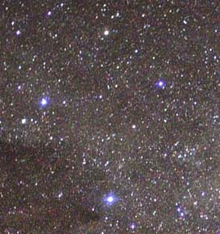
The Southern Cross

6 August 1945
“We were about 300 miles east of Tokyo when we received urgent orders to turn and steam away from Japan as fast as possible. We didn’t know what was up but we knew it was big. We were only told that the U.S. was about to drop a large bomb on Japan. Shortly after that they dropped the Atomic Bomb on Hiroshima. Even at that distance we felt the effect of low pressure shock waves. They came in three stages: ‘Whoosh, Whoosh, Whoosh’. Our clothing stood out away from our bodies in the direction of the blast; especially our pants legs.”

The first bomb is a Uranium bomb which is dropped on Hiroshima, located about 400 miles southwest of Tokyo. It is followed three days later by a Plutonium bomb which is dropped on Nagasaki – approximately 300 additional miles southwest of Hiroshima; both cities are on the southwestern end of Japan. The Imperial Japanese Empire then surrenders. It is called V-J Day (Victory in Japan). Back home in the USA the population is overjoyed. The writer can remember the day clearly. Miniature U.S. flags are tied to automobile aerials and the drivers go and drive around and around the city square blowing their car horns. The people line the sidewalks as if they are gathered for the Christmas Parade. They are laughing and crying at the same time. The boys are coming home!

“The South Dakota had received orders to go to the Philippines and pick up Gen. MacArthur and bring him to Tokyo Bay for the signing of the armistice aboard the South Dakota since she was the most decorated battleship of the war with 15 battle stars. But since President Truman was from Missouri, he countered that order and directed that the USS Missouri would take our place. This caused a lot of hurt and anger among our crew. They were so mad at Truman that I think if they could have gotten their hands on him they would have tried to pull his insides out of him through his ears. It was a tough pill to swallow but we complied.

15 August 1945 – Tokyo Bay
“It had only been five days since the second Atomic Bomb had been dropped when the Missouri and her escorts arrived with Gen. MacArthur, the fleet waited at sea in deep water until 48 of us from SoDak boarded four whale boats and entered the bay with orders to secure all naval personnel and then to liberate the POW camps in and around Tokyo.

“There were only about four ships anchored there. We didn’t see any carriers so we headed for the largest one that we could find and went aboard. It was named Nagato and had once been Adm. Yamamoto’s flag ship prior to his death in 1943. Ten months previous to this she had been at the Yokosuka Naval Yards for repairs.

“U.S. frogmen had earlier discovered that the anchor chain of the Nagato was intertwined with a rubber electrical cable which connected underwater with onshore communications when the ship was berthed. Our commanders were fearful that this cable might be part of a booby trap which might blow up all the ships in the bay, including ours. Our first objective was therefore to cut this cable. After it was cut, one of our men contacted our command by walkie talkie and our ships began maneuvering into the bay channel with the help of a Japanese harbor pilot who had been taken aboard.

“I was later told that when this pilot boarded SoDak, his eyes got as big as the headlights on a Ford Truck. He looked at the crew, with no uniforms and then his eyes crawled over the gun emplacements that covered our ship. He just shook his head and turned to face Japan and to perform his task. The South Dakota obediently took her place next to the Missouri.

“As we boarded the Nagato a Japanese admiral approached us, but I motioned to him with my rifle to go to his quarters. I wanted to arrest him personally. He turned out to be Rear Adm. Ichiro Yokoyama who would participate in the signing of the armistice later on that day. I didn’t know it at the time but I guess I was making history. I arrested the ‘big fish’. I asked him for his name, rank and serial number as required by the Geneva Convention. I wrote it down on a piece of paper and then began looking around his quarters. I kept him in the corner of my eye.

“He noticed my apprehension and in perfect English said, ‘Son, you don’t have to worry about me, I know the war is over.’ ”

“I spotted a sword on the bulkhead and asked permission to take it down. He assented. It had a razor sharp edge and a needle-like point. It was a Hari- Kari sword.

“The admiral then said, ‘I know how you Americans like souvenirs. Go ahead and take it. I won’t be needing it’.

“I locked him in his quarters and observed that the other members of our group had secured the rest of the Jap crew below decks.

“I brought the sword home in my trunk. The same procedure was followed on the other Jap ships in the bay and then we turned our attention to the POW camps. We didn’t know it at the time, but there were four divisions of crack Japanese Marines on shore, but they didn’t bother us.

“The Japanese inhabitants of Tokyo didn’t know what to expect from us. They had all hidden underground when they spotted the U.S. Fleet. We later learned that their leaders had told the population that the Americans would kill every one of them.

“When we arrived in Tokyo, not a living thing could be seen; no birds, no traffic, no people. Unoccupied cars lined the streets; some with the engines still running. Gradually we were able to coax the people to come out of hiding. ‘An old Japanese lady gradually approached me making eye contact all the while. I wondered if she might have a grenade so I held up my hand for her to stop. I counted to ten and then decided she didn’t have a grenade. I then motioned for her to approach. When she reached me she knelt down and began kissing my shoes. I gently raised her up and pointing to my feet I shook my head indicating ‘No’. I pointed to my face and I smiled. I next pointed to her face indicating for her to smile also. She did so revealing very bad teeth. I gave her a chocolate bar. With the help of one of our men who spoke a little Japanese, she directed us to the POW camps so that we could begin the liberation of the prisoners.

“The camps were located about five miles outside of town. When we arrived at the first one, I told the Jap guard to open the gate. He told me in perfect English that he had studied at UCLA and said that he didn’t have that kind of authority. I had told the marine behind me that if the guard made a false move with his weapon to shoot him with his BAR (Browning automatic rifle) and to shoot him more than once. I then told the guard pointing to the BAR ‘Here’s your authority. Open that gate or he’ll cut you in half’! The guard then opened it very quickly. We began bringing the starving prisoners out. Many of them were so near death that we carried them in our arms like children. We loaded them on the whale boats and sent them out to the hospital ships. It was very moving. We thanked God that it was finally over.

“Later on that day I was summoned to the radio room aboard the Missouri. There stood General Douglas MacArthur, Adm. Chester Nimitz and Adm. William Halsey, I was directed to send the Morse code message to Washington D.C. that the war was over. On my first attempt I got no reply from the Navy Wave radio operator in Washington.”

Adm. Halsey said, “Son, won’t that girl answer you?”

I replied, “No Sir, I don’t have enough transmission power.”

“I then received a message from one of our distant stations offering to relay the message. I thanked him but declined. I wanted to send that message all the way home myself.

“I contacted the radio engineering officer on the intercom and told him I needed all the transmission power he could generate. He complied and later told me that he had connected three large transmitters together and that the resulting electric field produced such high static electricity that a ten pound sledge hammer held near the metal bulkhead drew a large blue spark which arced from the metal wall to the head of the hammer.

“With all of that power I was able to transmit a strong enough signal to reach Washington D.C. At 1449 hours 14 Aug I transmitted the message to NSS radio that the war in the Pacific was over. I only transmitted at about 35 wpm so that she could copy me. Her answer came back promptly and I began to transmit the message.

Gen. MacArthur asked me, “Son, how do you send code that fast?”

“I replied, ‘Practice Sir; practice. A Life Magazine photographer was on hand and took the picture shown below. It was a time of great celebration.”

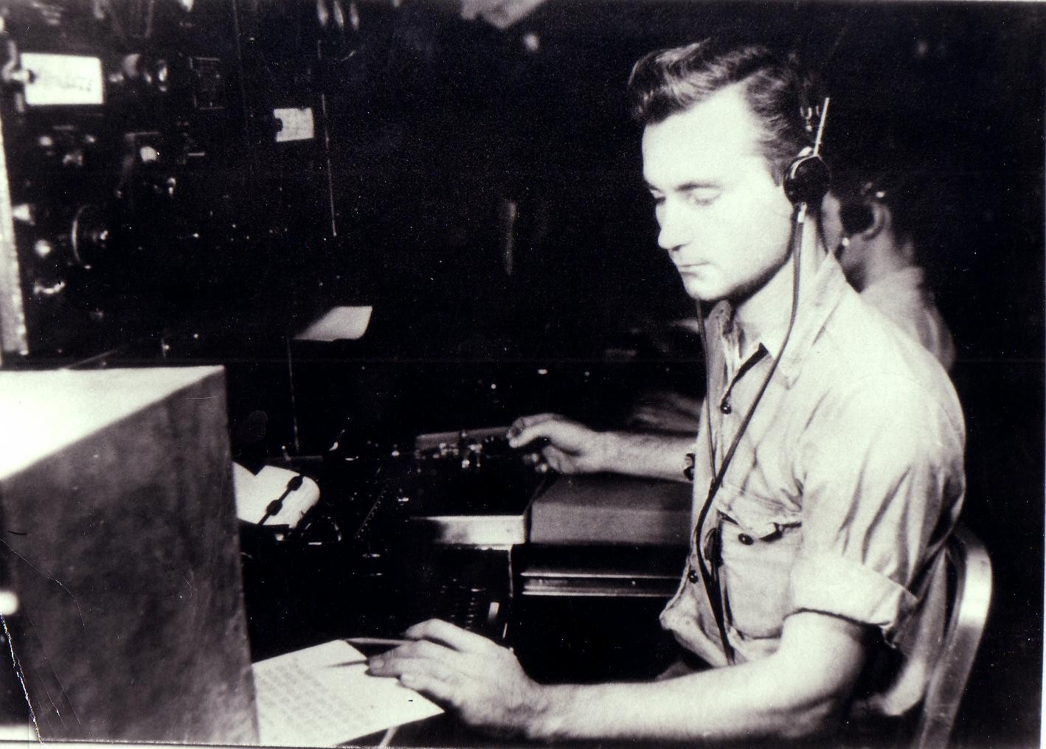
Henry Stewart transmitting the message from
Tokyo Bay to Washington D.C.
Appears on cover of Life Magazine, August 1945
The following newspaper article is typical of the many stories that appear in the U.S. Press:

1945: Allied nations celebrate VJ Day
“Japan has surrendered to the Allies after almost six years of war. There is joy and celebration around the world and 15 August has been declared Victory in Japan day. The end of war will be marked by two-day holidays in the UK, the USA and Australia. After days of rumor and speculation, US President Harry S. Truman broke the good news at a press conference at the White House at 1900 yesterday. He said the Japanese Government had agreed to comply in full with the Potsdam declaration which demands the unconditional surrender of Japan.

“Supreme Commander General Douglas MacArthur will receive the official Japanese surrender, arrangements for which are now under way. Later, in an address to a crowd that had gathered outside the White House President Truman said: ‘This is the day we have been waiting for since Pearl Harbor. This is the day when Fascism finally dies, as we always knew it would.’
“But he warned that the task of creating a lasting peace still lay ahead. At midnight, the British Prime Minister Clement Atlee confirmed the news in a broadcast saying, ‘The last of our enemies is laid low.’
“He expressed gratitude to Britain's allies, in the Dominions of Australia and New Zealand, India, Burma, all countries occupied by Japan and to the USSR. But special thanks went to the United States ‘without whose prodigious efforts the war in the East would still have many years to run’.
“The day coincides with the state opening of Parliament which took on an air of a victory parade. Thousands braved the rain to watch King George VI and the queen driven down the Mall in an open carriage. Later tonight, the King addressed the nation and the Empire in broadcast from his study at Buckingham Palace at 2100. ‘Our hearts are full to overflowing, as are your own. Yet there is not one of us who has experienced this terrible war who does not realize that we shall feel its inevitable consequences long after we have all forgotten our rejoicings today‘.
“The Royal Family greeted cheering crowds from the Palace balcony. Princess Elizabeth and Princess Margaret later mingled with the crowds outside the Palace. Historic buildings all over London are floodlit and throngs of people have crowded onto the streets of every town and city shouting, singing, dancing, lighting bonfires and letting off fireworks.
“But there were no celebrations in Japan - in his first ever radio broadcast, Emperor Hirohito blamed the use of ‘a new and most cruel bomb’ used on Hiroshima and Nagasaki for Japan's surrender.
"Should we continue to fight, it would not only result in the ultimate collapse and obliteration of the Japanese nation but would lead also to the total extinction of human civilization."
2 September 1945
The day the world has been waiting for has finally arrived. The formal signing of the armistice by representatives of the Empire of Japan, the United States of America, the Republic of China, the United Kingdom, the Union of Soviet Socialist Republics, the Commonwealth of Australia, the Dominion of Canada, the Provisional Government of the French Republic, the Kingdom of the Netherlands and the Dominion of New Zealand will be participating. The ceremony lasts 23 minutes and is broadcast throughout the world.

The ceremony takes places on the USS Missouri’s veranda deck, alongside her second sixteen-inch gun turret. At 9:02, Gen. MacArthur opens the ceremonies with an inspiring statement calling for "a better world ... a world founded upon faith and understanding -- a world dedicated to the dignity of man and the fulfillment of his most cherished wish -- for freedom, tolerance, and justice."

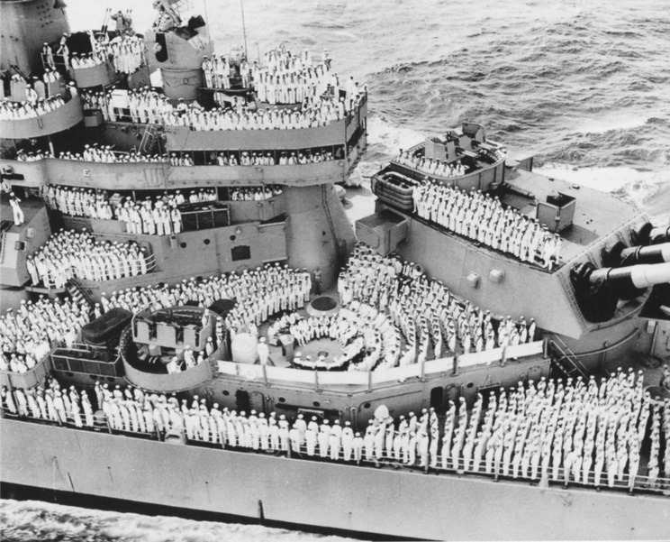
Armistice aboard USS Missouri

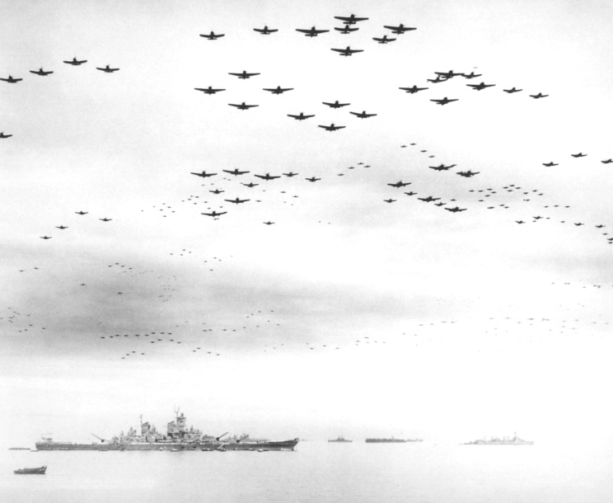
Allied Arial Salute above Tokyo Bay
on 2 September 1945

Following the signing Gen. MacArthur’s stirring closing comments are broadcast around the world:

“Today the guns are silent. A great tragedy has ended. A great victory has been won. The skies no longer rain with death...The entire world lies quietly at peace. The Holy Mission has been completed...We stand in Tokyo today reminiscent of our countryman, Commodore Perry, ninety two years ago. His purpose was to bring an era of enlightenment and progress by lifting the veil of isolation to friendship, trade and commerce to the world. But alas the knowledge thereby gained of Western science was forged into an instrument of oppression and human enslavement...We are committed...To see the Japanese people are liberated from this condition of slavery...Today, freedom is on the offensive, democracy is on a march.”

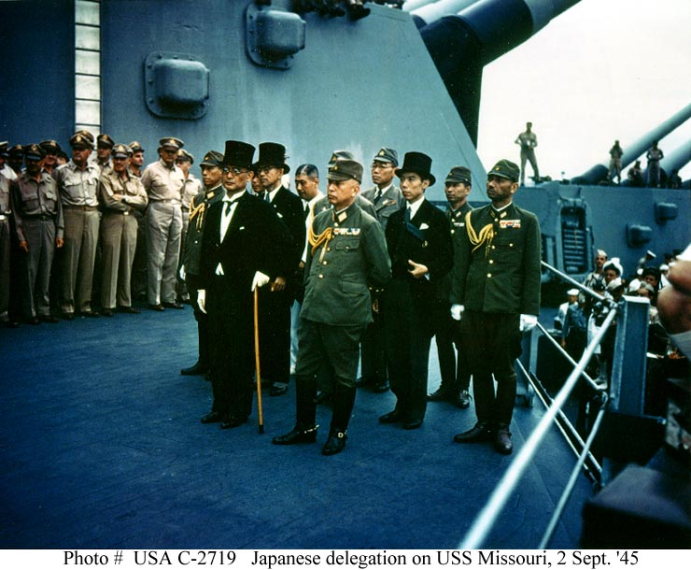
Japanese Armistace delegation:
Rear Adm. Ichirro Yokoyama who was arrested by
Henry Stewart is dressed in whites; third row, right end.

Chapter 12
20 September 1945 - Departure
The USS South Dakota leaves Tokyo Bay and heads for home via Okinawa and Pearl Harbor. On 15 October 1945, serving as Halsey’s flagship SoDak leads the Third Fleet into San Francisco Bay. Thousands of Americans line the Golden Gate Bridge to welcome the men home. The South Dakota remains in San Francisco until Navy Day on 27 October 1945. Two days later she sails for San Pedro. She is in Los Angeles harbor 22 November for the brief ceremony that marks Adm. Halsey's retirement from the sea-going phase of his naval career. The New Year finds her underway for the Philadelphia Naval Yard for overhaul. In June 1946 she is attached to the inactive Atlantic 16th Fleet. She is decommissioned 31 January 1947 and placed in reserve at the Philadelphia Naval Yard. She remains there until 1962 when scrapping operations commence.
Henry decides not to make a career of the navy. He has had enough. He tries to pick up his life where he left it, but all his loved ones are gone. His mother has died, his wife has been killed and he doesn’t know where his little girl is. He takes a job as a truck driver traveling all over the United States for the next 40 years.

Following the decision to scuttle the South Dakota, former crew members petition the navy to let them have relics from the ship to be placed at a memorial located at Sioux Falls, SD. Some relics are acquired, but the veterans have to transport them to the memorial site at their own expense.

They are provided with the flag, mast, anchor, chain, RADAR and some of the Teakwood flooring. It is the same mast that Henry clung to during the end of the Battle of Guadalcanal when he was almost hit by the 500 pound bomb. As it turned out, the bomb exploded about 10 feet away from him, but he was protected by armor plating. The hearing in his left ear was permanently damaged. He learned to compensate by learning to read lips.

The deck of the ship had been made of Teak which is the densest of all wood. It is so dense that it will not float and water cannot penetrate and rot it. This Teak is planed and used to cover the internal walls of the memorial building and to make benches for visitors. In 1970, the crew members begin getting together to share their experiences aboard BB57. Reunions are held odd numbered years over the Fourth of July weekend at the memorial.

In order to give visitors an idea of the great size of the ship, the memorial is constructed with a concrete wall that outlines her outer perimeter. The mast and RADAR are located where they stood on the ship as well as the anchor and chain. An enclosed building houses plaques with the names of her crew.

At the first reunion that Henry attends, he examines a plaque containing the names of the dead. He finds the name of a friend who used to follow him around asking him questions, hoping to get the latest scuttlebutt from Henry because he was the captain’s radio man and had privileged knowledge.

Henry says, “I told him what I thought he ought to know. There were some things I couldn’t tell anyone because it was classified.”

At the plaque, he runs his fingers over Johnson’s name and in his mind he sees the young sailor’s face and hears his voice. Henry is so overcome with emotion that he passes out and has to be rushed to the nearest hospital. He recovers soon thereafter.

Henry marries Myrtle Lee Jordan in 1964 and together they finally find his daughter, Jackie, in Baton Rouge, Louisiana after a search of 47 years. She is teaching nursing at LSU. Their acquaintance is fabulous. She really loves him and has been trying to trace him all that time, too. When he finally locates and calls her he opens the conversation as follows:

“Jackie, you don’t know who this is do you? Who would you like to see the most? This is your daddy.”

She replies, “I knew I had a daddy, but I didn’t know what your name was and they wouldn’t tell me.”

The two are reunited and spend a year getting to know each other before she dies. They talk about all the time that has gone by and how much they love and enjoy being with each other.

Henry converts to The Church of Jesus Christ of Latter-Day Saints in 1978 and that’s how the writer made his acquaintance.

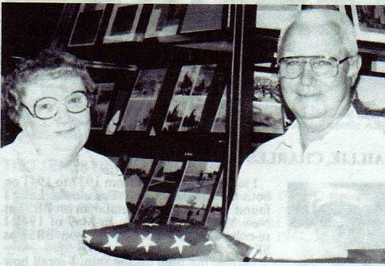

At the 1985 reunion, Hilda Buus presents Henry
with the flag that flew on SoDak’s mast.
In the final analysis, Henry Stewart served his country because he loved her and treasured freedom. The price of freedom is blood. It is worth preserving.

Epilogue

“My memory of SoDak and the friends who gave their lives are with me each day of my life. After all, we only experience such greatness once in a lifetime.

“Out of the naval war in the Pacific a new star was born – Task Force 58, a fleet unit conceived specifically to meet the demands peculiar to the war against Japan. This great task force, the most powerful in the world and made up of the finest fighting ships ever built was a closely coordinated, near-perfect combination of many types of combatant ships, each calculated to do a specific job but all working together to accomplish one objective – the defeat of the enemy wherever he might be found.

“Our fiercest battles were against enemy Japanese invasion forces who were attempting to recapture Guadalcanal from the Battle of Santa Cruz on 26 October 1942 and the Second Battle of Savo Island (Guadalcanal), 14 and 15 Nov 1942. Displaying her tremendous fire power as she went into action for the first time on 26 October 1942 Battleship X repeatedly attacked the heavy waves of enemy dive bombers and torpedo planes which swept down upon our carrier task forces off the Santa Cruz islands and during the furious two hour battle and destroyed approximately 38 of the hostile aircraft.

“Shortly after midnight three weeks later, when our battleships intercepted several Japanese fleet units near Savo Island, we fired our salvos accurately to score direct hits on two enemy cruisers and sunk them almost immediately. Continuing her effective fire as another column of Japanese vessels was sighted, she destroyed an additional cruiser, assisted in sinking a battleship, and damaged the two remaining ships before she was forced to retire from the battle area for repair from several major caliber shell hits.

“A gallant fighting ship, the South Dakota, complemented by skilled officers and men contributed materially to our successful defense of Guadalcanal and to our decisive air and sea victory against the Japanese in the southern Solomons.

“And then the bomb came …

“America will always need sailors and ships and ship-borne aircraft to preserve her liberty, her communications with the free world and even her very existence. If the deadly missiles with their apocalyptic warheads are ever launched at America, the navy will still be out on blue water fighting for her, and the nation or alliance that survives will be the one that retains command of the oceans.”

Henry looks deeply into my eyes and says, “You can write all the books you want, but don’t ever call me a hero. I’m not a hero. My heroes are still over there at the bottom of the Pacific Ocean”.

Bibliography:
1. Japanese Destroyer Captain, by Capt. Tameichi Hara, Ballantine Books, New York, 1961
2. The True Story of BB57, USS. South Dakota: The Queen of the Fleet, by Jack Kilgore & Associates, Dallas, Texas, 1987.
3. Day of Deceit: The Truth about FDR and Pearl Harbor, by Robert B. Stinnett; Simon & Shuster, New York, 2000.

